Cup of Joey is to connect meaningful relationships to a more fulfilling future. Through respect and honoring your purpose in you, we can create a safe and welcoming environment that shares resources, opportunities, and ideas. We are a coffee meetup for innovative ideas. One cup of coffee between you and your future.

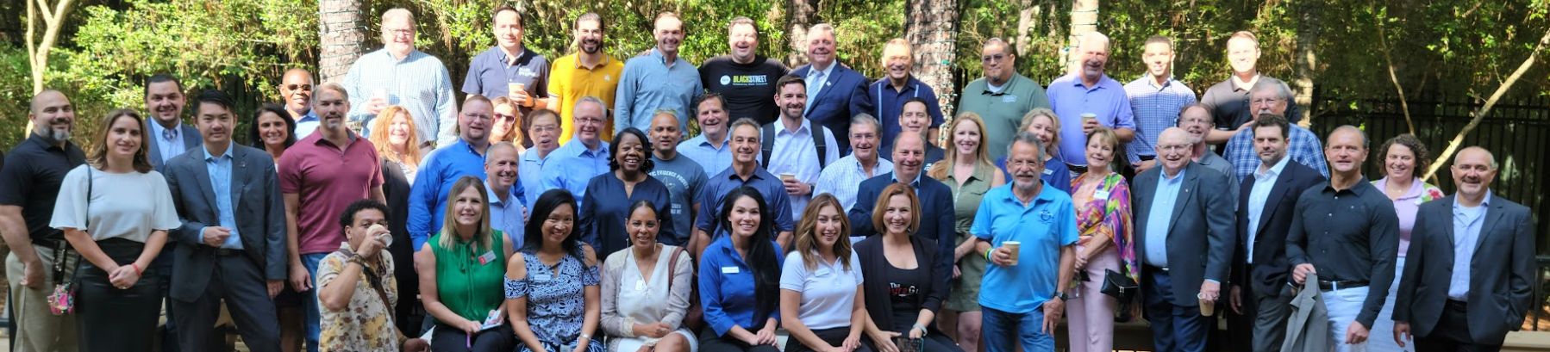

Connection is a human fundamental! Add coffee, energy, #humanconnections, #transition, #innovation, and #technology, you get a glimpse of the #future. If you missed the previous events, Just Show Up! The event where connections are made, and relationships develop.
#cupofjoey. All you need is your "why"!

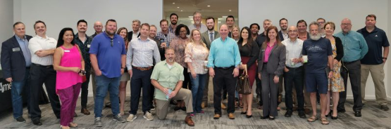

COJ is #purpose #culture! Time to develop #friendship, #businessconnections, and #humanconnections. Cup of JoeY - Downtown, Sugarland, Space Center, Katy, and The Woodlands

